User manual:
When you open this app, nothing display till client connects
When client connects, information about client’s computer will show.
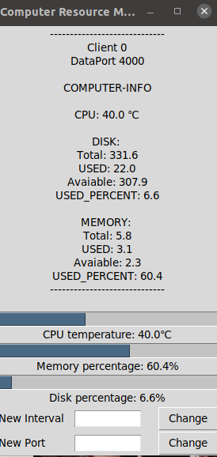

We have several buttons textboxs here,
if you wanna change Interval, insert into “New Interval” textbox then press “Change”
if you wanna change Port, insert into “New Port” textbox then press “Change”
(this Port is a TCP port that you want to send your data to there)

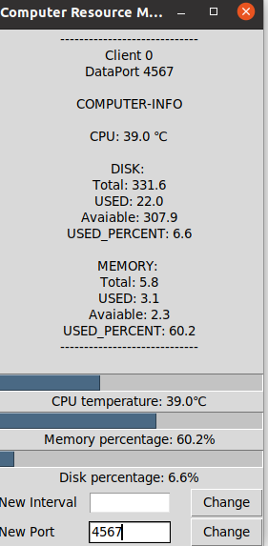
- Change Port

- Change Interval
Of course you don’t see anything change but when you use it, use will see
